Advance topics in a function

1. Write a function add to add two numbers and call the function in another file.

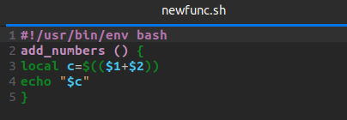

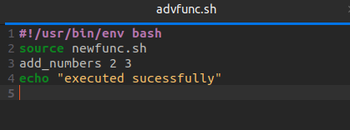

Terminal

